WEEK 7

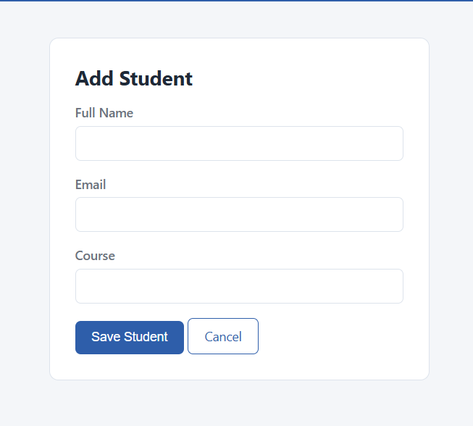
Figure 16 Student form
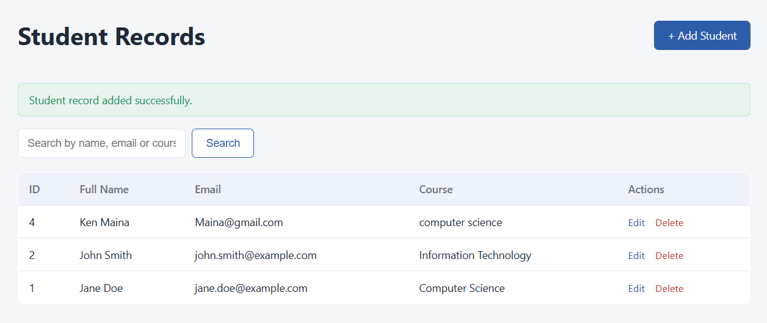
Figure 17 successful added student
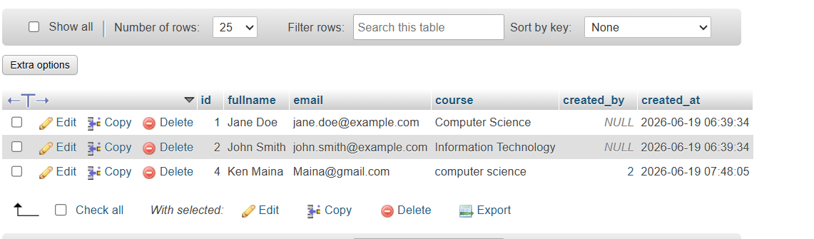
Figure 18 successfully saved in the database

